

**Auto parts Garage**

Web programming class project, acadimec year 2023 /2024

|  |  |  |  |  |
| --- | --- | --- | --- | --- |
| Student Name in English | Student Name in Arabic | Student ID | Section time as shown in zajel | Work percentage |
| Oday yamak | عدي عبد الرؤوف يمك | 11923786 |  | 50% |
| Osamah abdallah | اسامه عبد الله | 12111983 |  | 50% |
|  |  |  |  |  |

Date/time

---------------------------------------------This section is intended for the Instructor---------------------------------------

|  |  |
| --- | --- |
| **Topic** | **Mark** |
| Project Idea |  |
| Project Complexity |  |
| Project Tools |  |
| Project Requirements and Modeling |  |
| Project Discussion |  |
| Project Completeness |  |
| Project Output Results or reporting |  |
| Project Administration and Management |  |
| Project Report |  |
| Team work |  |
|  |  |

**Project Idea:**

Garge management software is used to manage all your vehicles, cars and motorcycles. It provides you with a complete garage management solution that enables you to check the status of your vehicles and motorcycles, track their bills, monitor their usage, and generate usage reports on a daily basis or time periods. This program also provides you with advanced features that will help you manage your car during service in the garage

**TABLE OF**

**CONTENTS**

**1 6**

**INTRODUCTION references**

**2**

**Tools used in the project**

**3**

**Project database EER**

**4**

**discussion about your project GUI work**

**5**

**conclusion**

An entire software called Auto Parts Garage Management System has been created to improve and simplify the daily operations of the garage. With the help of Oracle, PHP and SQL Developer, this project aims to provide a user-friendly interface.

INTRODUCTION

The main goals of this system are accuracy and efficiency. This technology ensures proper management of supplies, reduces errors and increases customer satisfaction by maintaining a database of available auto parts. This software is for garage owners who are thinking of making their workshop repair service center computerized.

System features include the ability to create custom reports and create invoices, bills, and receipts. It also facilitates the documentation of goods received from vendors. Only authorized personnel, specifically the manager, are allowed to edit user information in the system, which is regulated by the login method.

The auto parts garage management system's ability to manage item modifications and additions is one of its main features. Users can quickly track transactions, record purchase invoices, and update inventory levels, resulting in seamless inventory management.

This project provides a powerful and reliable garage management solution and is a very useful tool to improve your workshop management process. In this workshop management software, we can see Garage Management Software (GMS) working. GMS is used by garage owners and garage managers to manage their workshops in a more efficient manner. It is also used by companies that want to increase and decrease their productivity



**Tools used in the project:**

**1- PHPStorm** is an integrated development environment (IDE) specifically designed for PHP development. It provides a comprehensive set of features for coding, debugging, and testing PHP applications.

**2-** **XAMPP** is a cross-platform web server solution that includes Apache, MySQL, PHP, and Perl. It is used for setting up a local development environment on your computer.

**3-** **phpMyAdmin (for Database using MySQL)** is a web-based tool for managing MySQL databases. It provides a graphical user interface to interact with the MySQL database.

**ER DIAGRAM**

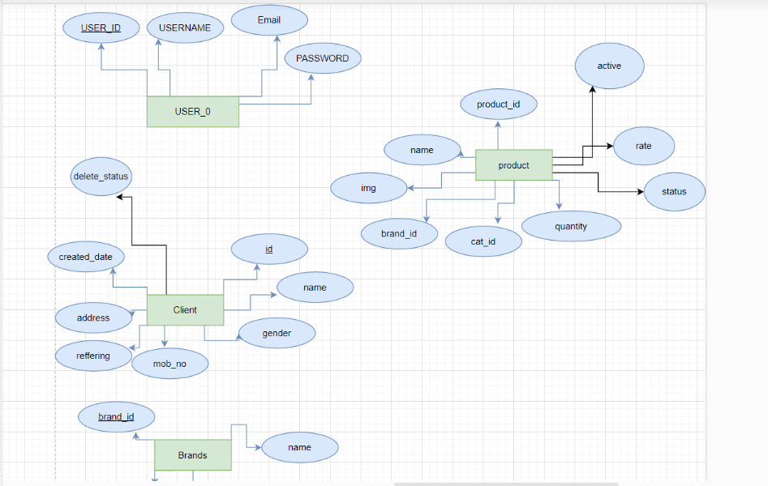

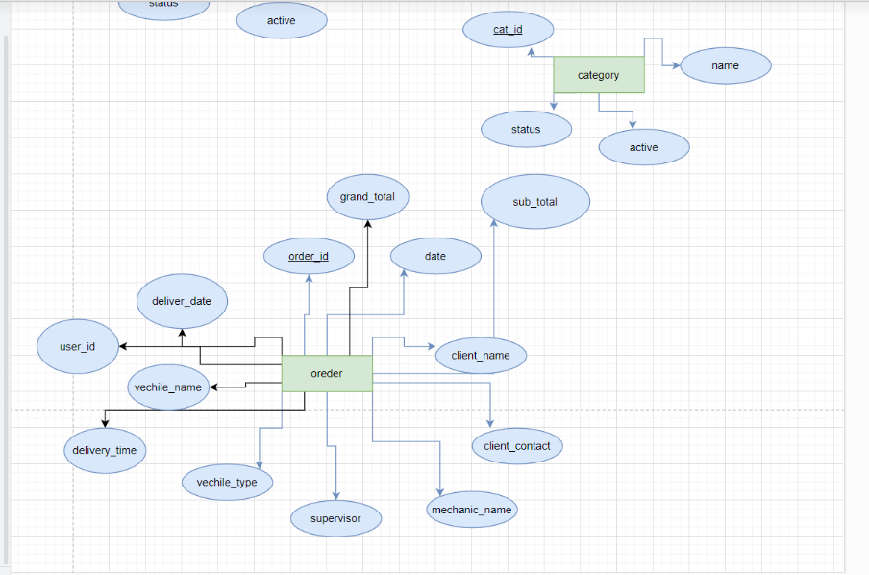

**the relation:**

order table: 1-many : many in order table ,1-many with client table many in the order table side

many-many : between order and product table so we construct a new table named order_item

which have a realtion with order table 1-many

and with product_table 1-many

user table have a realtion on it self because there are one manager and tha manager is from the users

**IMPLEMENTATION**

Implementation description

The aim of this application is to manage car parts and various functions of the garage.

List of modules:

* Login page
* Admin window
* User window
* brands
* categories
* orders
* manage_website
* item/client
* Reports pages

**GUI FOR THE PROJECT: -**

**1-** **login pageThis page Here is the Login Form Design of the Garage Management System you can enter the username and password**

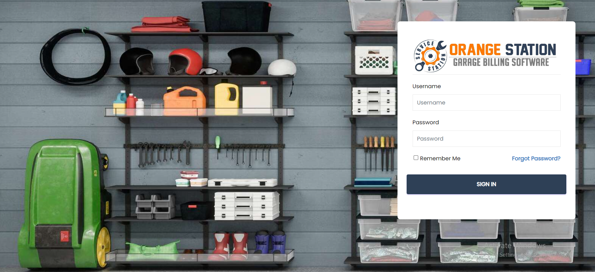

**2-** **This page: If you forgot your password, set a new password via your email address after clicking “Forgot Password”.**

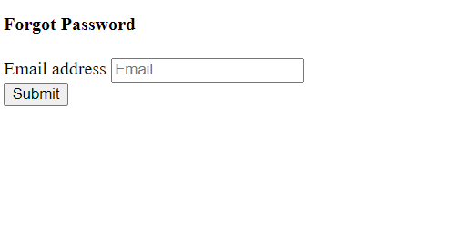

**Next:** **After entering your email address to set a new password, you will receive a password reset email.**

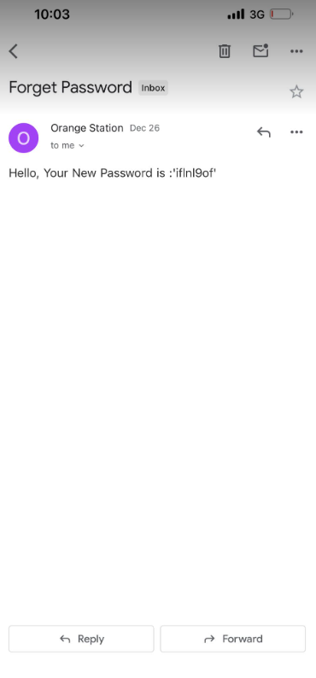

**3-** **Dashboard page**

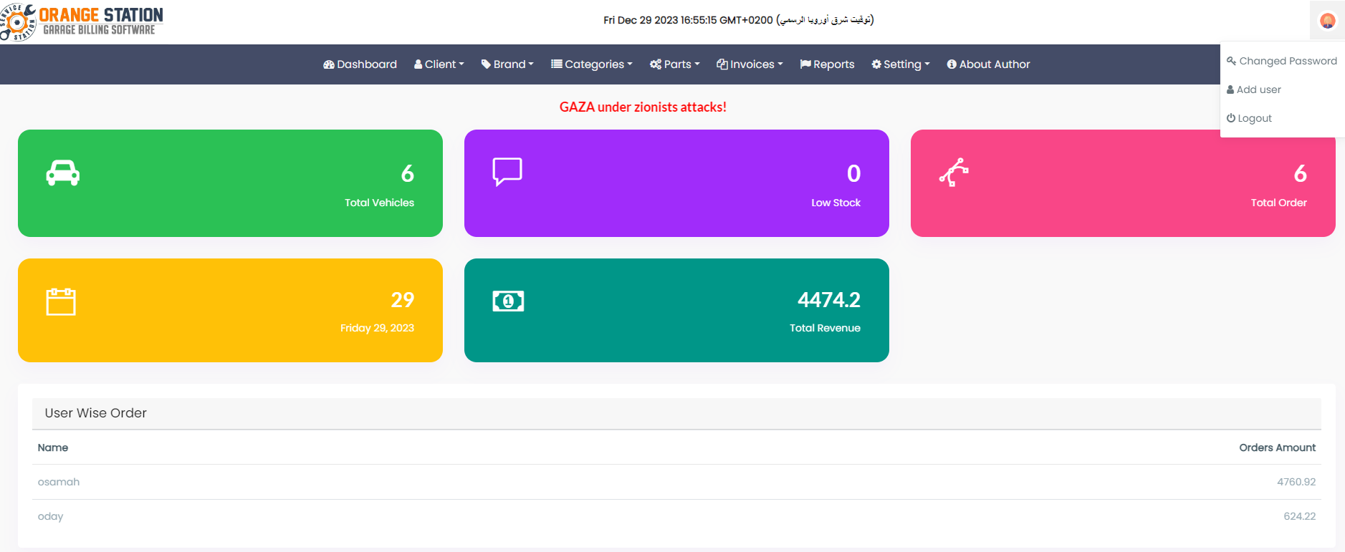

**4-** **This page is dedicated to adding more than one user so they can control the site**

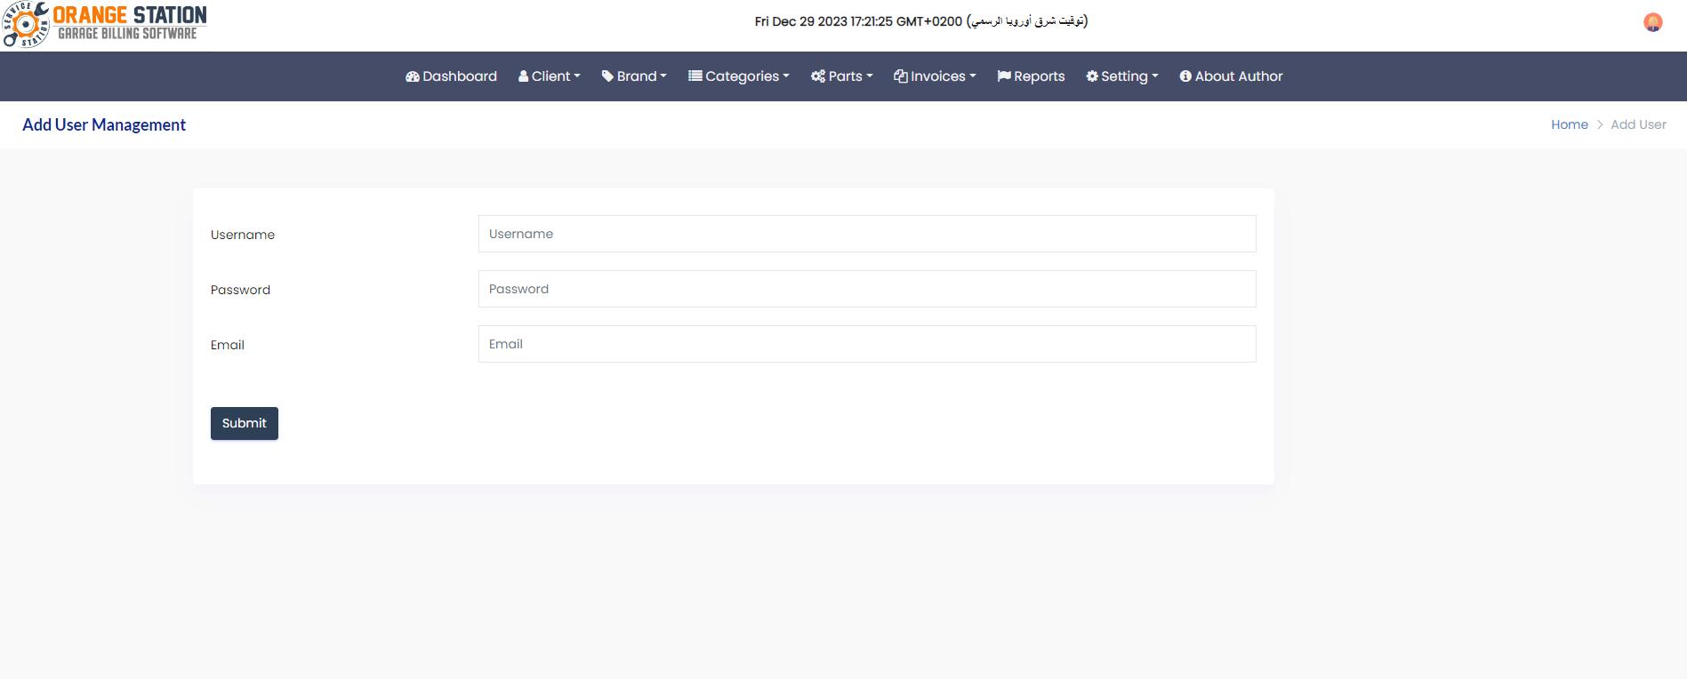

**5-client page ->add client** This page is to add information for any customer who wants to purchase from my garage

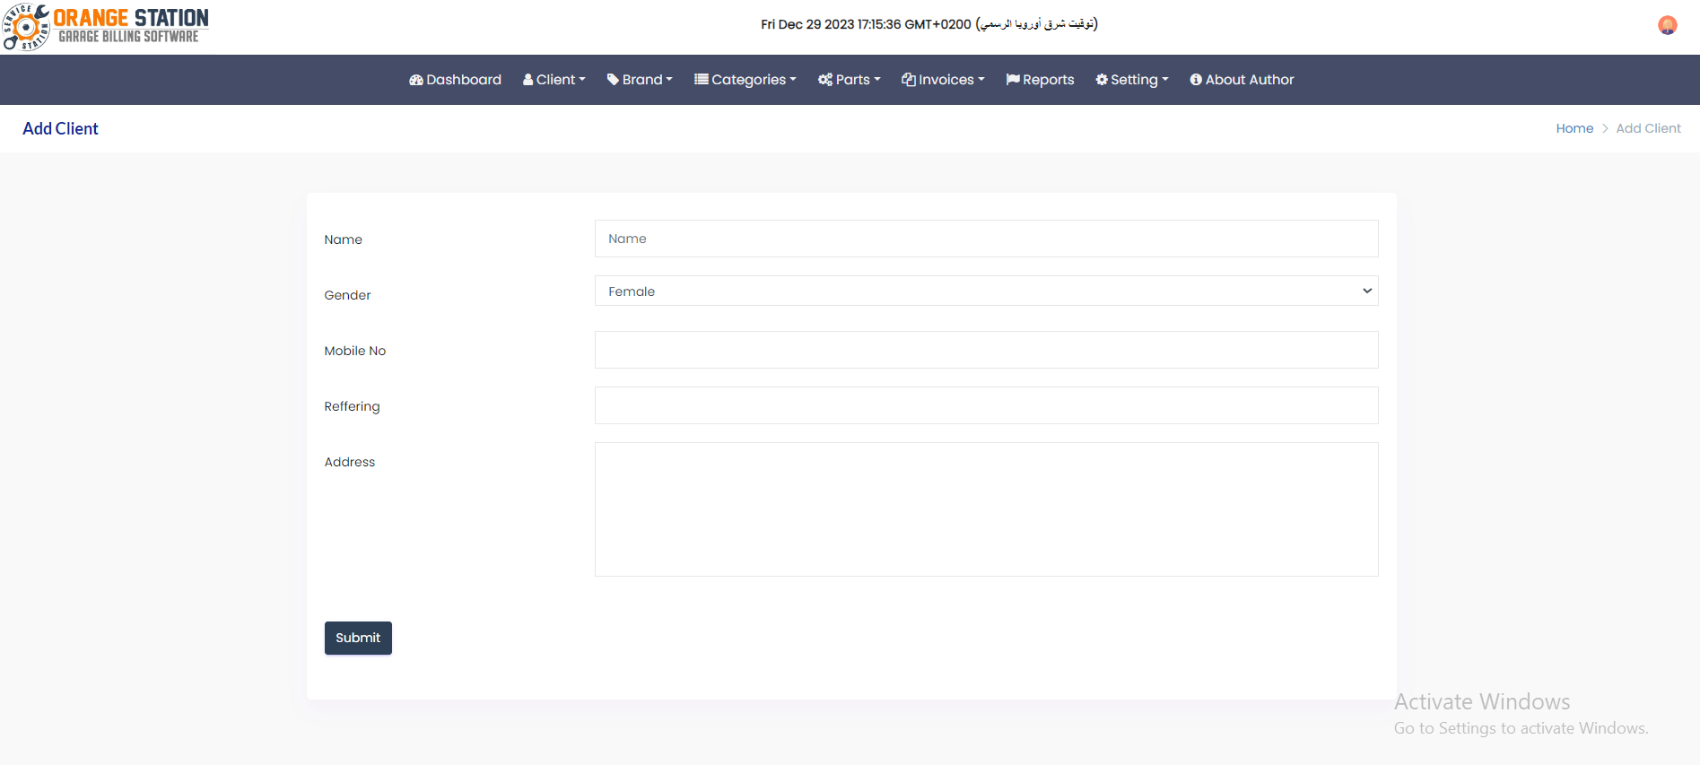

**6- client page ->manage client** This page is for editing or deleting information about recently added customers

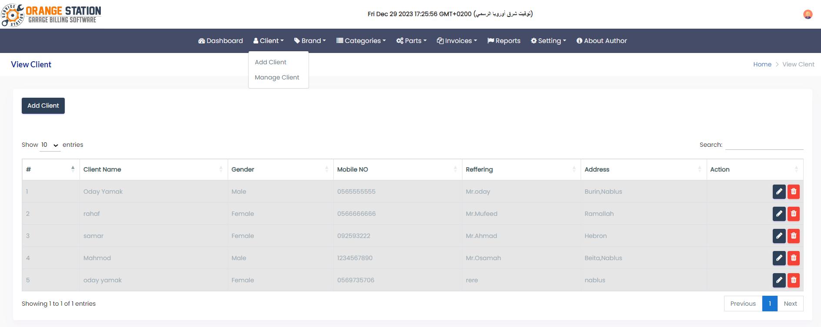

**7-brand -> add brand** This page is to add brands of parts available in my garage

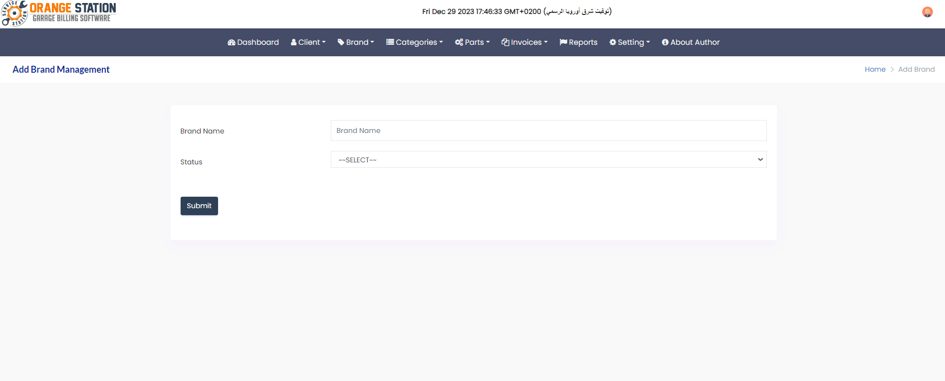

**8- brand -> manage brand This page is for modifying and deleting the brand names of the parts in the store and the status field to indicate whether this part is available at available or when the stock is sold out at not available**

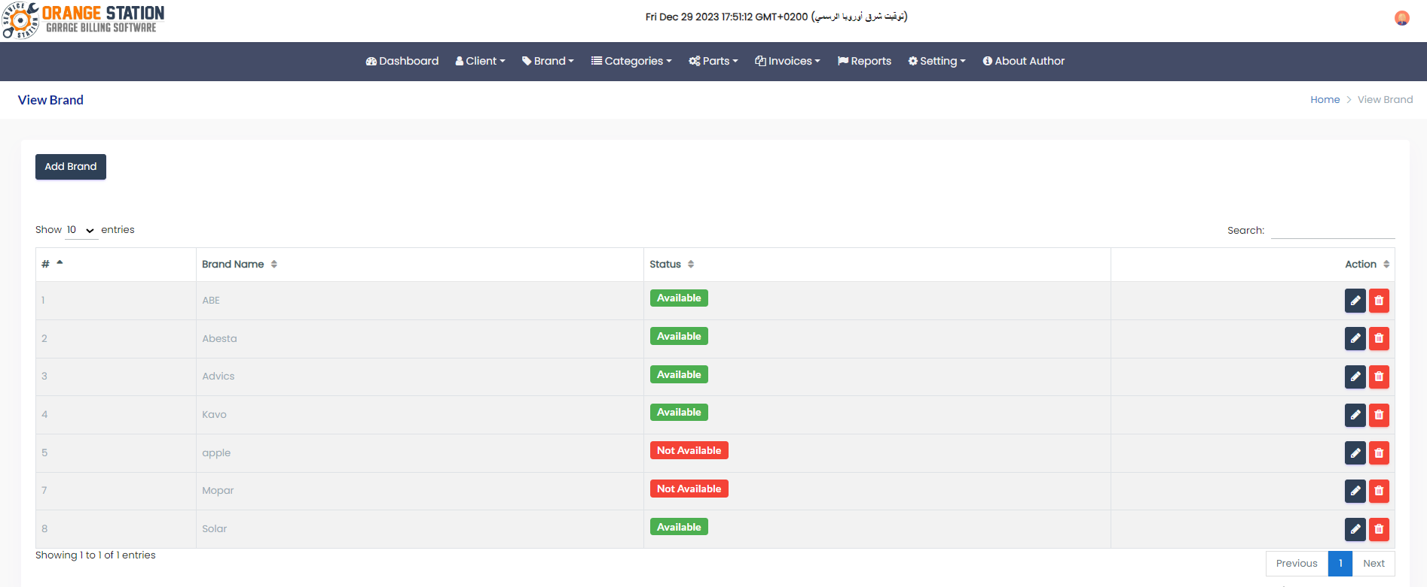

**9-categories ->add categoriesThis page is to add the types of parts that will be purchased after, whether they are organizing bricks, lighting, wheels, and so on**

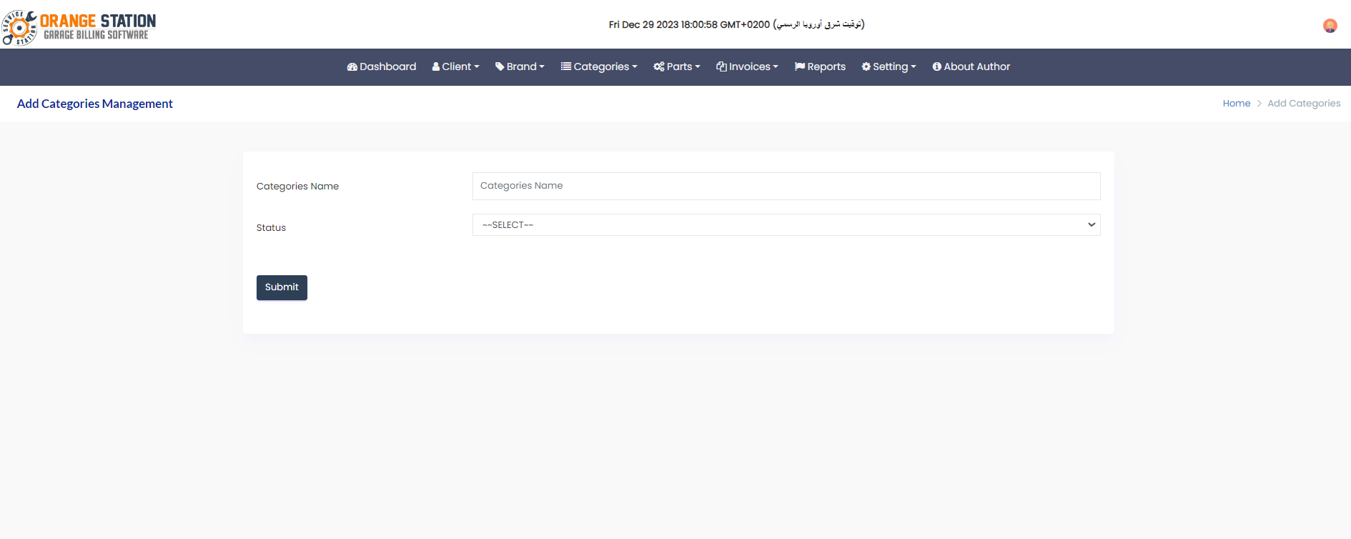

**10-categories ->manage categories This page is dedicated to modifying and deleting the types of pieces that have been added**

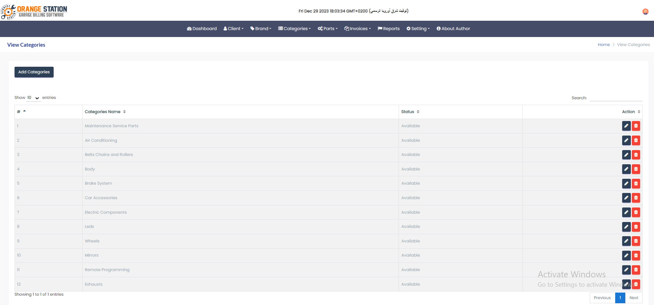

**11-parts -> add parts This page is to add all the information related to the spare parts available in my garage**

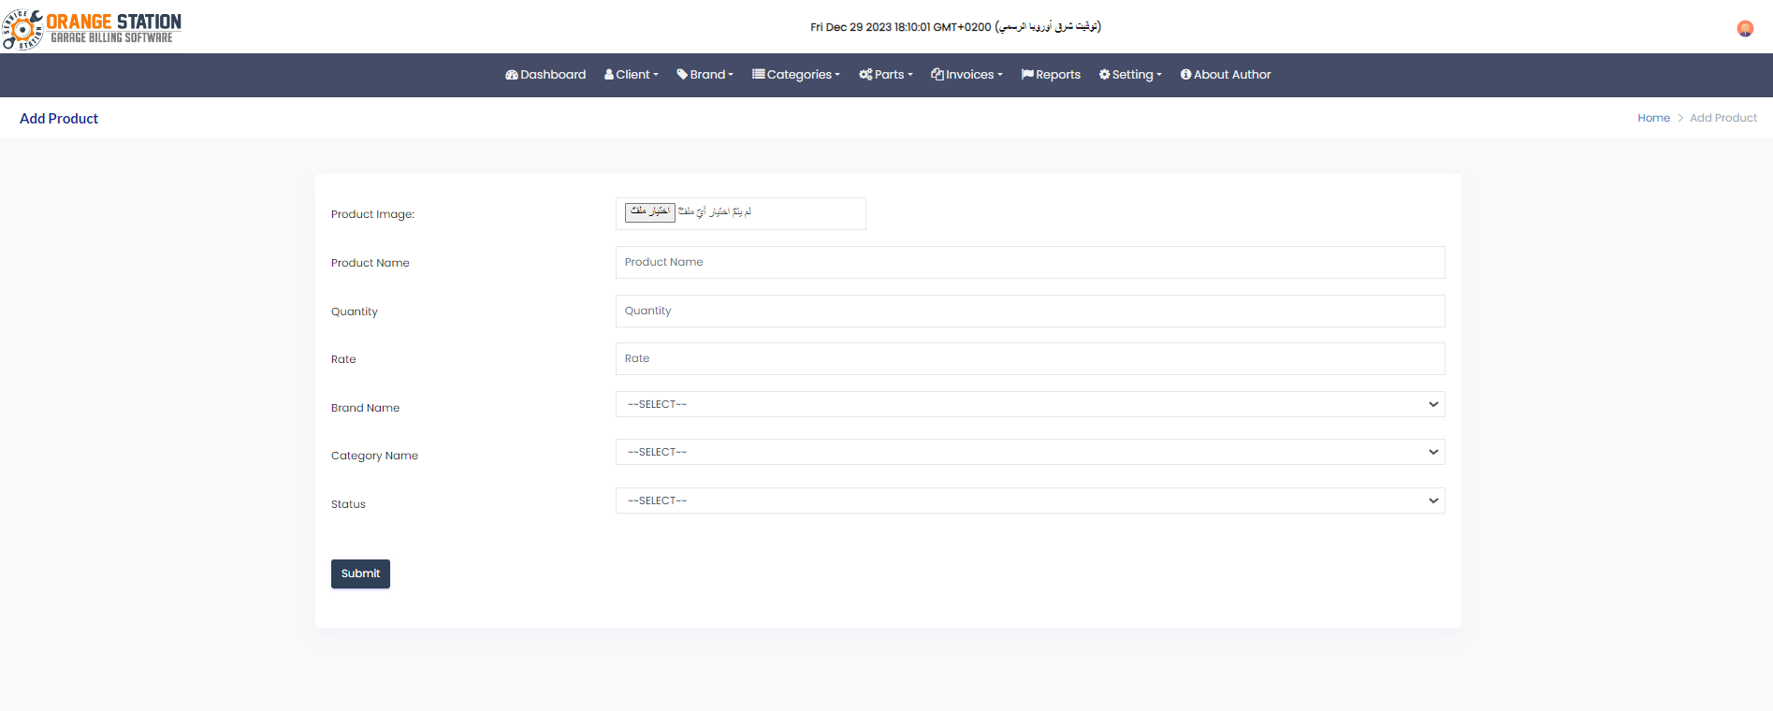

**12- parts -> manage parts This page is intended to edit and delete all information regarding spare parts available in my garage**

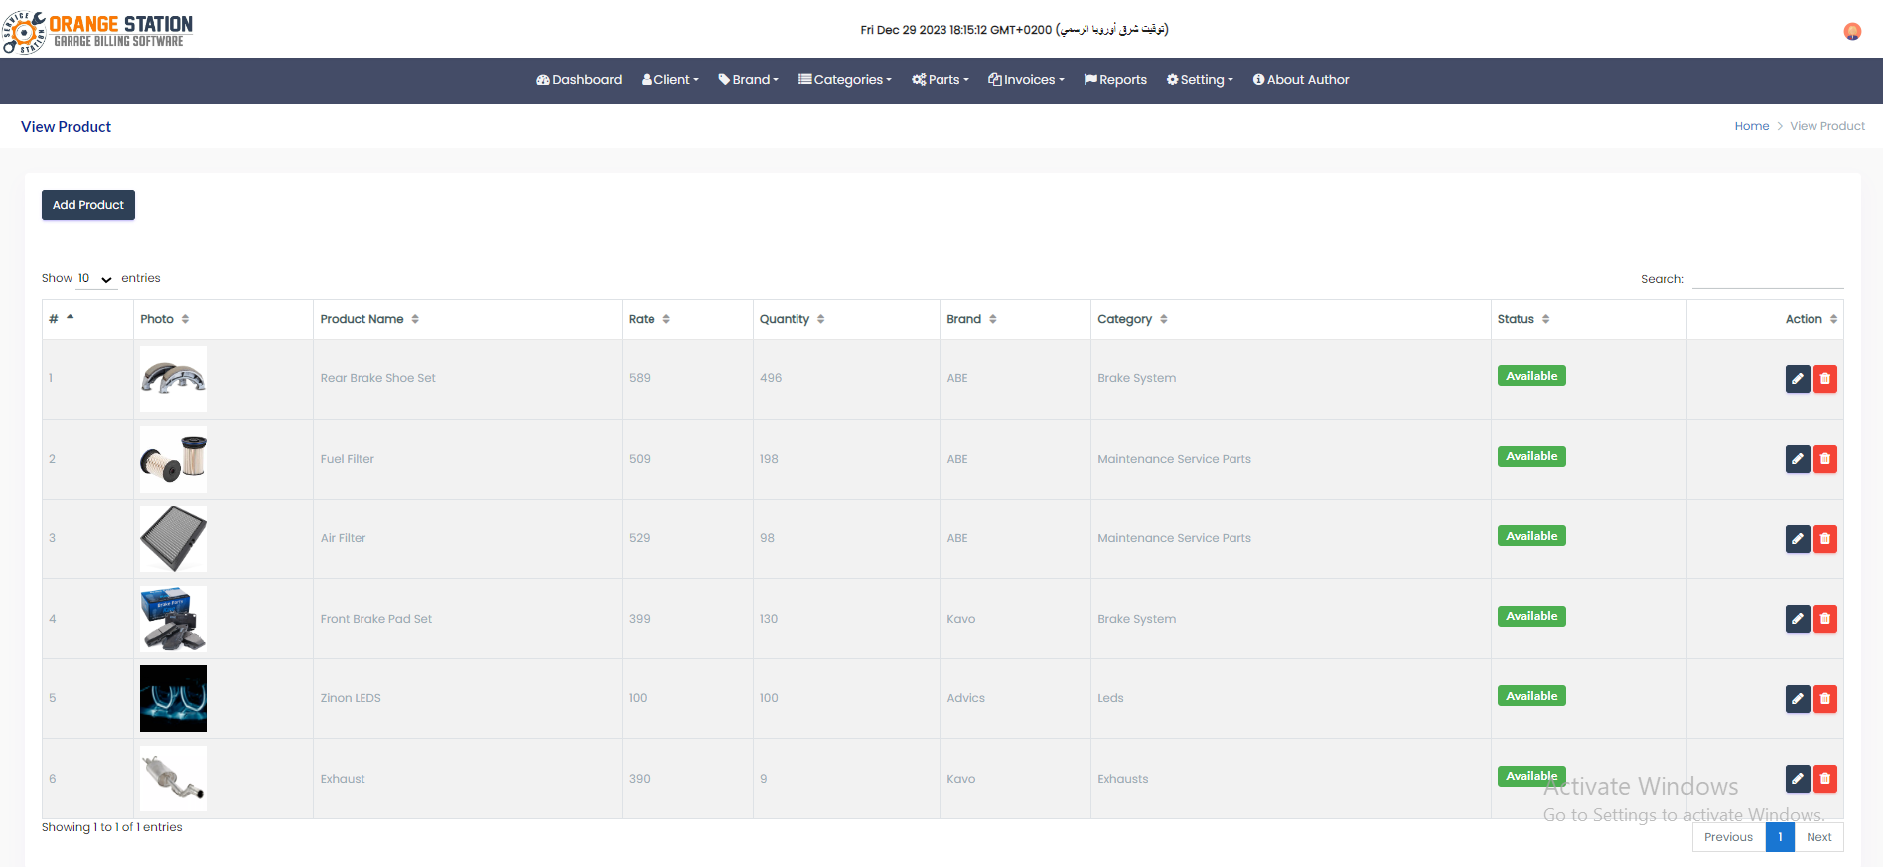

**13-invoices-> add invoices This page works to add an invoice for specific customer purchases. This invoice contains all the customer information, products, etc.**

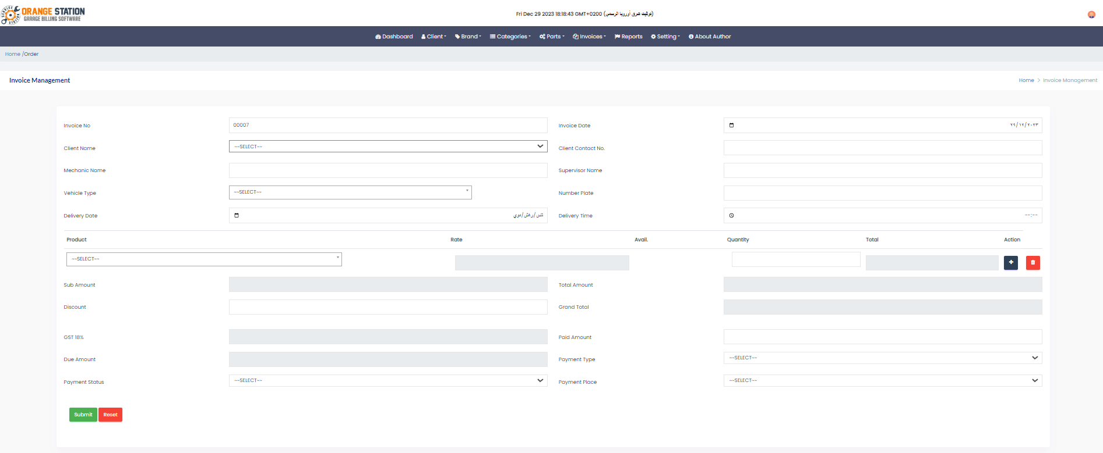

**14- invoices-> manage invoices** **This page displays all the billing information that was previously added, meaning it shows garage sales**

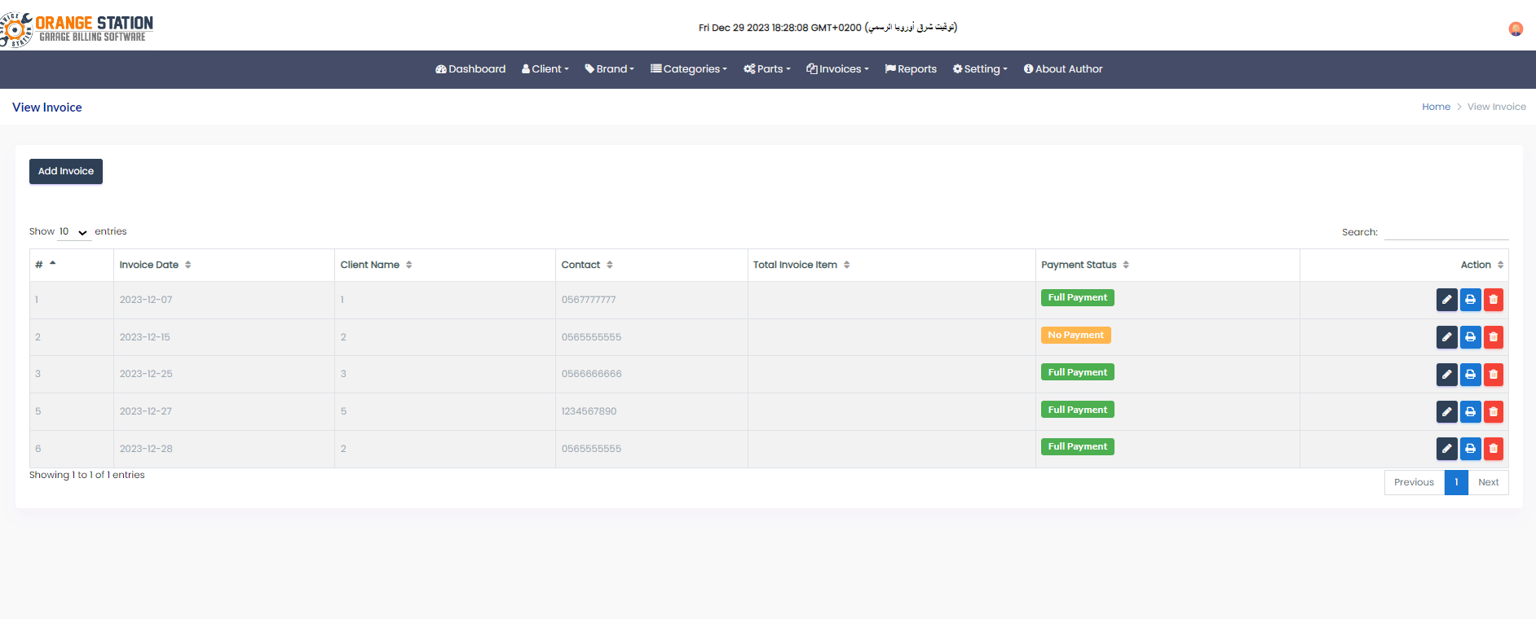

**15-** **When you click the print button on the previous page, this page will show you the buyer’s invoice that you want to print.**

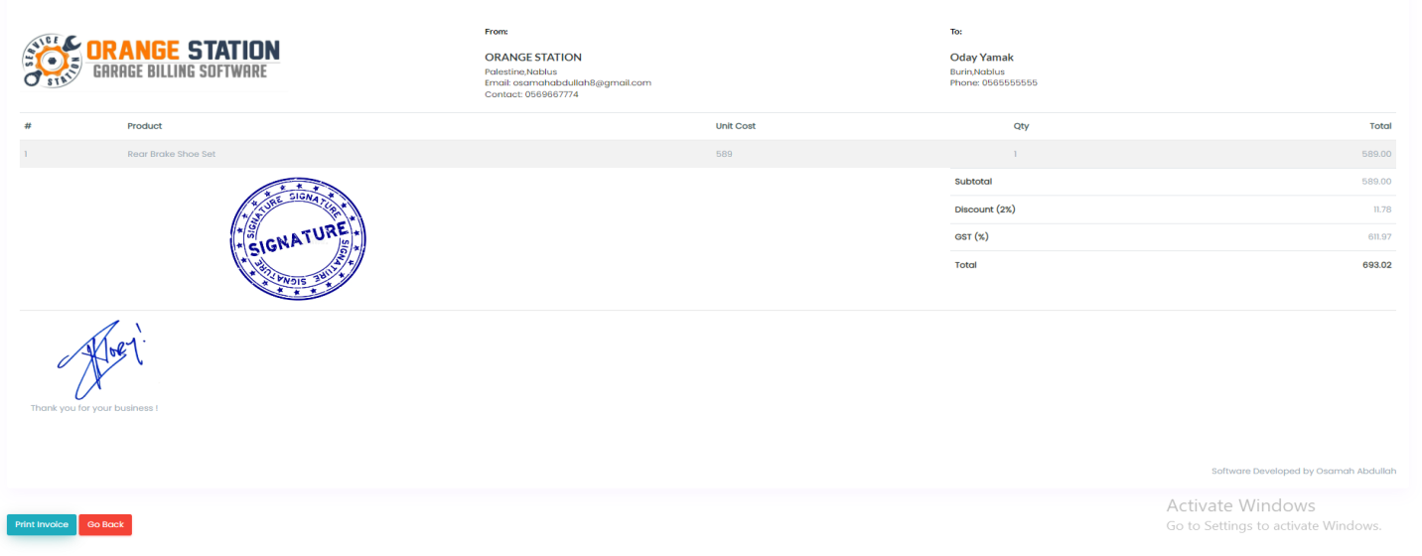

**16-** **When you click the print invoice button on the previous page, this page will show you the buyer’s invoice that you want to print, which is connected to the printer**

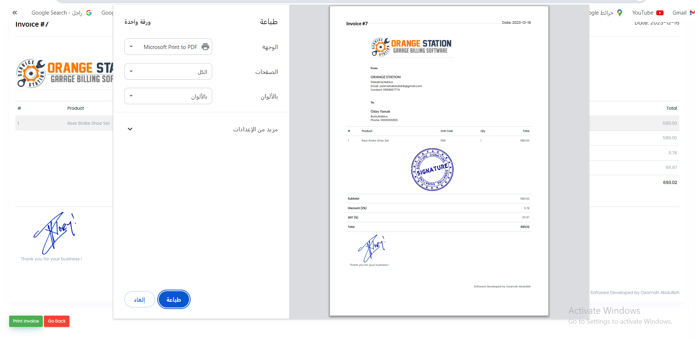

**17-Reports** Show all profits during a certain period

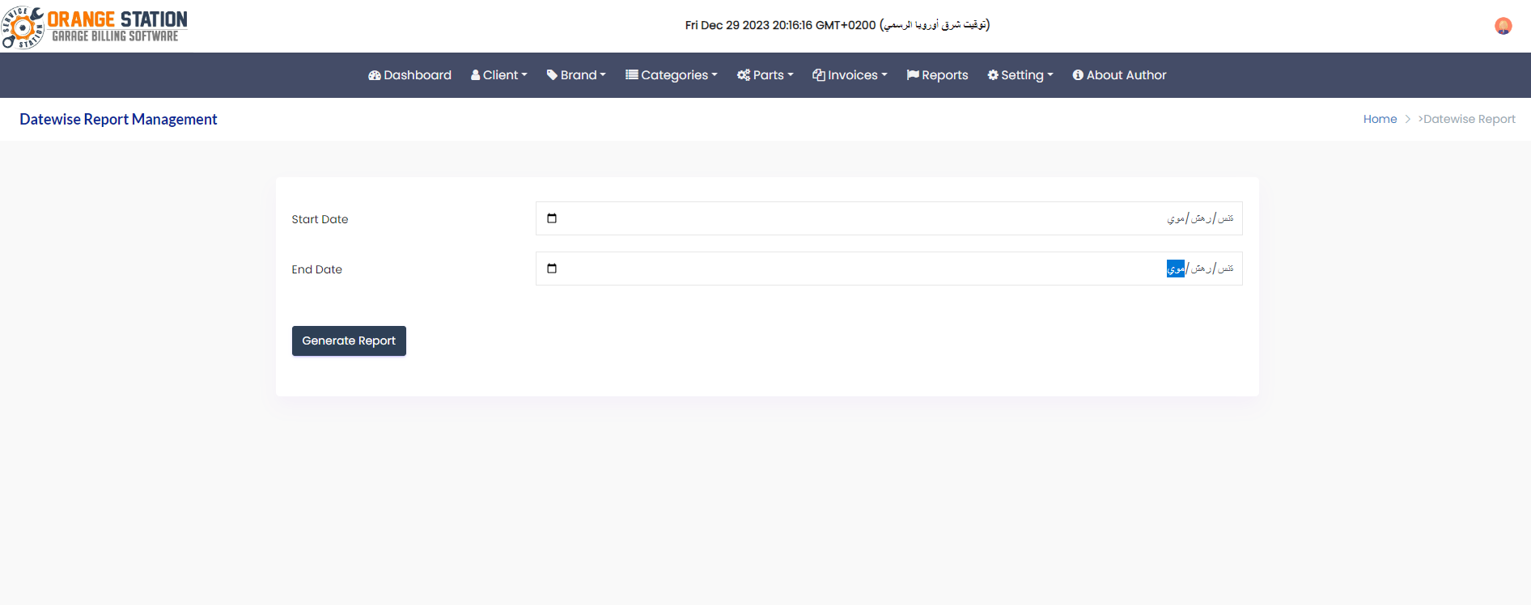

**18- When you press the Generat report button, you will see a list of profits for each employee in the garage**

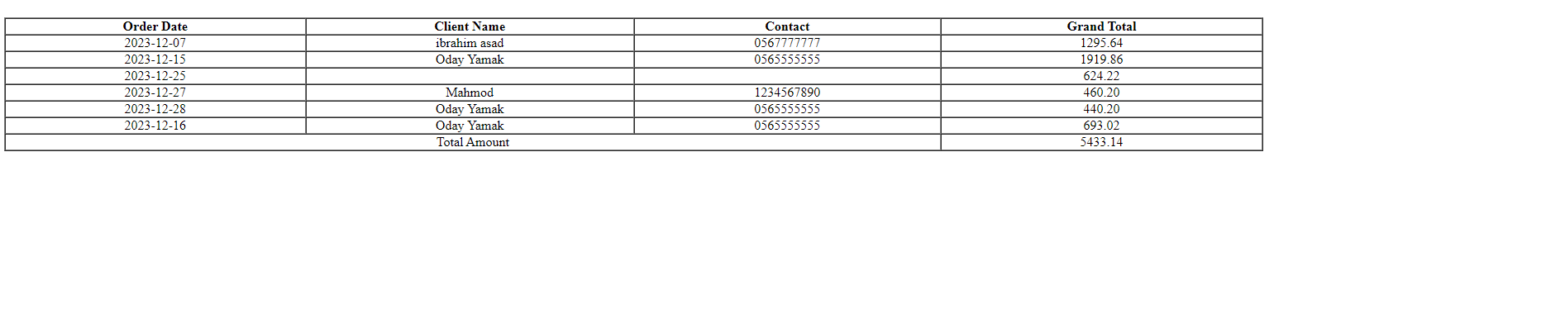

**19-setting -> Web Management This page is dedicated to editing some special matters related to my website**

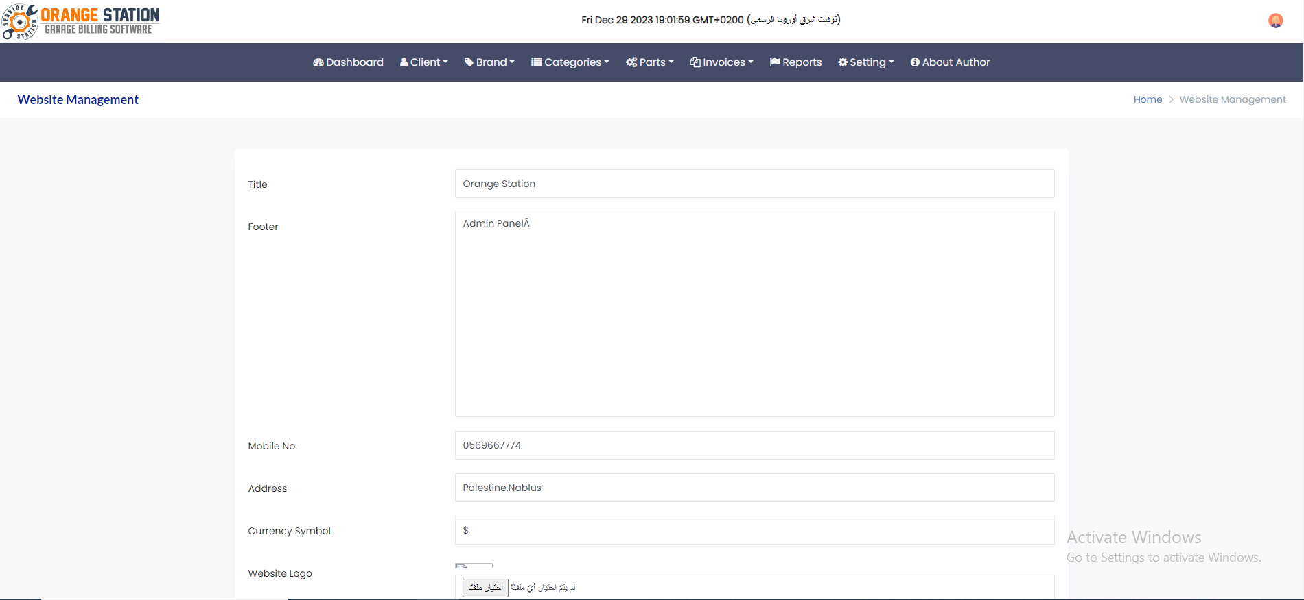

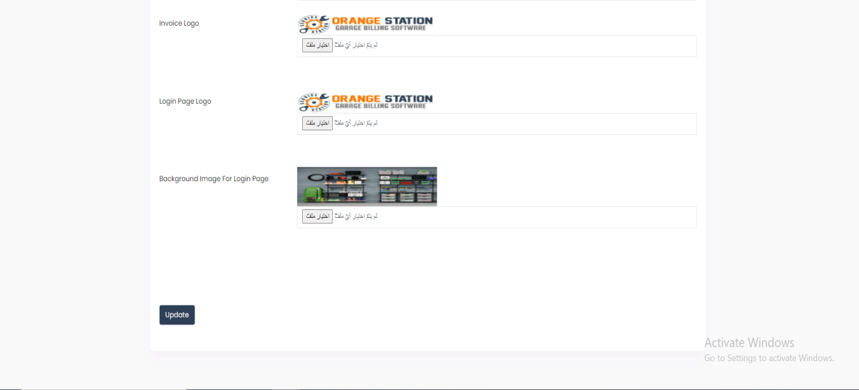

**20-About Author When you click on this option, the Facebook page of the owner of this website will appear**

conclusion

**The management of the auto spare parts site tends to keep all the data obtained from users, including spare parts sales information and the profits achieved by their owners, in this database using SQL instructions. This facilitates the process of understanding between the owner of the auto spare parts garage and its customers, so it is not possible Manipulating money because everything will be saved and recorded**

**Refrences :**

**1.Bootstrap lib**

**2.W3SCHOOLS**

**3.LEARN PHP IN ARABIC:YOUTUBE**

**4.DATATABLES SITE**